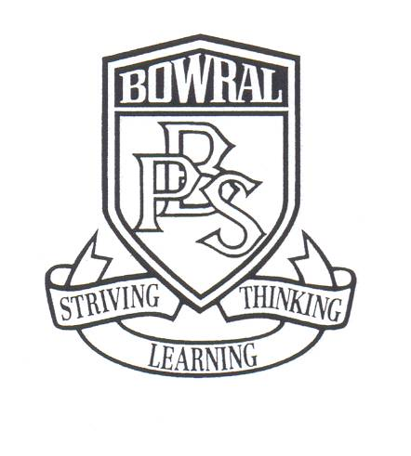
Bowral Public School
PO Box 865
Bendooley Street
BOWRAL NSW 2576

Telephone: (02) 4861 1086 Facsimile: (02) 4862 1004
Email: bowral-p.school@det.nsw.edu.au

YEAR SIX KIAMA BEACH EXCURSION
PARENT INFORMATION AND CONSENT FORM

EXCURSION DATE | COST | PAYMENT DUE BY
Friday 8 December | $26 | Friday 17 November

Dear Parents, 3 November 2017

Year Six will be going on an excursion to Kiama Beach on Friday 8 December 2017 to participate in the Beachsmart – Surf Awareness program run by the South Coast Life Saving Association. The Beachsmart day involves students in activities which are conducted on beaches all around Australia as part of the Surf Life Saving Association’s Nippers program. Activities include sprints, flags, water wading and team relays. They will also participate in a Surf Awareness presentation which focuses on beach safety, surf safety and the role of Surf Lifesavers in the community.

This excursion has been planned to supplement the safety component of the PDHPE curriculum.

Travel will be by seat-belted coach via Macquarie Pass. Students need to arrive at school at 8.30am. We will depart from Bowral Public School at 8.45am and return to Bowral Public School at 3.00pm in time for normal dismissal.

Accompanying staff are Rachel Gentz, Maggie Galloway and Eva Canute. All attending staff and the life savers running the program have current first aid training.

Students should be prepared for a full day in the sun. Students are not required to wear school uniform on the day and should come dressed in suitable clothing for a day at the beach, including swimmers. Please ensure that they have adequate sun protection, including hat, sunscreen and a long sleeved shirt. Students will not be permitted to swim but will be involved in water activities in knee deep water and will get wet.

Please note that electronic devices, including smart phones, iPods and tablets, are not allowed to be taken on this excursion. There will be no opportunity to purchase food or drinks so please ensure that students have enough food and water for the day.

The cost of this excursion is $26.00. Please complete the attached permission note and return it, together with full payment, to your child’s class teacher by Friday, 17 November 2017. Unfortunately, no late payments can be accepted. Payment may be made by our parent online payment option which is accessed on the ribbon of our web page by selecting $ - make a payment. Payment can also be made by cash or cheque.
If you have any questions about this event, please do not hesitate to contact your child’s teacher.

Kind regards,

_____________________________ ____________________________
Eva Canute, Excursion Coordinator Wendy Buckley, Principal

Bowral Public School
KIAMA BEACH EXCURSION
PARENT INFORMATION AND CONSENT FORM

I do / do not consent for (Name)_____________________ of (Class)_____ to participate in an excursion to Kiama Beach on Friday 8 December 2017.

I am aware that my son/daughter will be involved in activities which involve wading in shallow water at a surf beach.

In relation to the proposed water activities, I advise that my child is (please circle appropriate option)

STRONG AVERAGE POOR NON SWIMMER

I give/do not give permission for my child to participate in the water activities.

My child has the following special needs:

My child has the following medical needs: (State any medication needed)

I give / I do not give permission for my child to receive medical treatment in case of emergency.

Medicare Number    | Valid to | / | Position on Card

Signature: | Print name:
Daytime contact phone number | Date:

Payment may be made by our parent online payment option which is accessed on the ribbon of our web page by selecting $ - make a payment. Payment can also be made by cash or cheque.
Due date for payment is Friday 17 November 2017. Unfortunately no late payments can be accepted.
------------------------------------------------------------------------------------------------------
YEAR 6 BEACHSMART PROGRAM KIAMA BEACH

Payment Note: To the Teacher: _________________________ Class: ______________

I/We enclose $26 payment for my/our child ________________________ to attend the Beachsmart program at Kiama Beach on 8 December 2017.

Payment by: POP  POP receipt number ———–————
CASH    CHEQUE  Amount $ ……………  

