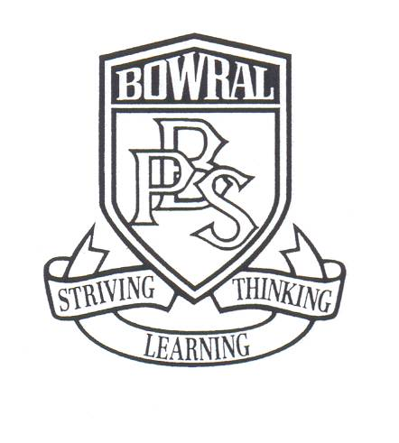
Bowral Public School
PO Box 865
Bendooley Street
BOWRAL NSW 2576

Telephone: (02) 4861 1086 Facsimile: (02) 4862 1004
Email: bowral-p.school@det.nsw.edu.au

STAGE THREE CRICKET CLINICS

4 September, 2017

Dear Parents,

As part of the Stage Three sport program, Stage Three students will have the opportunity to participate in a four-week cricket skills development program starting in Week 2 of Term 4. Run by qualified coaches from Cricket NSW, the planned activities will address many of the skills outlined in the PDHPE syllabus.

We encourage all students to participate in these engaging and enriching clinics.

The cost of this program is $12.00. Please complete the slip below and return to your child’s class teacher by Wednesday 20 September, 2017.

Unfortunately no late payments can be accepted. Payment may be made by our parent online payment option which is accessed on the ribbon of our web page by selecting $ - make a payment. Payment can also be made by cash or cheque to your child’s class teacher. If you are having difficulty making this payment, please do not hesitate to make an appointment to speak to Mrs Buckley or Ms Christie regarding financial assistance. Any arrangements made will remain confidential.

If you have any questions about this event, please do not hesitate to contact your child’s teacher.

Kind regards,

_____________________________ ____________________________
Eva Canute Wendy Buckley, Principal

------------------------------------------------------------------------------------------------
BOWRAL PUBLIC SCHOOL STAGE 3 CRICKET CLINICS

Payment Note: To the Teacher: __________________________________ Class: ___________

I/We enclose $12.00 payment for my/our child ________________________ to attend the Stage 3 cricket clinics in Term 4.

Payment by: POP  POP receipt number ———–————
CASH     CHEQUE 

