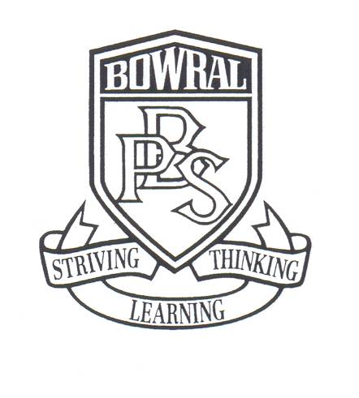**Bowral Public School**

PO Box 865

Bendooley Street

BOWRAL NSW 2576

Telephone: (02) 4861 1086 Facsimile: (02) 4862 1004

Email: Bowral-p.school@det.nsw.edu.au

EDUCATIONAL EXCURSION

PARENT INFORMATION AND CONSENT FORM

Monday 16 October 2017

Dear Parents,

As advised in the Stage Three newsletter sent home last term, the overnight excursion to Canberra is rapidly approaching. This excursion is strongly linked to the Year Six Term Four history unit focusing on government and democracy.

**The excursion will take place on Thursday 23 and Friday 24 of November 2017**. We will be leaving school at 7.15am on Thursday and returning at approximately 6.15pm on Friday. More detailed information regarding requirements for the excursion will be forwarded closer to the date.

**The cost of this excursion is $242.** This includes all meals, travel, accommodation, educational tours of Parliament House, the Australian War Memorial and the Australian Institute of Sport, entry to Questacon and ice skating. A full itinerary is attached to this note. The Australian Government recognises the importance of all young Australians being able to visit the national capital as part of their Civics and Citizenship education. To assist families in meeting the cost of the excursion, the Australian Government is contributing funding of $20 per student under the Parliament and Civics Education Rebate program. The rebate is paid directly to the school upon completion of the excursion.

Accommodation will be at Leumeah Lodge, a new, modern venue. Travel is by Kennedy Coaches. All coaches are fitted with seatbelts and feature the latest in safety and comfort.

Accompanying staff are Eva Canute, Maggie Galloway, Rachel Gentz and Greg Thompson. All staff members have first aid training.

**Payment for this excursion is due on Monday, 6 November.** Unfortunately no late payments can be accepted. Payment may be made by our parent online payment option which is accessed on the ribbon of our web page by selecting $ - make a payment. Payment can also be made by cash or cheque.

To confirm your child’s attendance on this excursion, please complete all sections of the permission note and ensure full payment of $242 has been made by the due date. It is important that we have updated medical information for each student for this excursion so please advise us in writing if there have been any changes to the medical information supplied at the beginning of this year.

This excursion is an important component of your child’s learning and we encourage all students to participate. If you are having difficulty in meeting this payment we may be able to assist. Please do not hesitate to make an appointment to speak to Mrs Buckley or Miss Christie as financial assistance is available. Any arrangements made will be confidential.

If you have any questions regarding this excursion, please do not hesitate to contact your child’s teacher.

Regards,

Eva Canute Wendy Buckley

Assistant Principal (relieving) Principal

**Bowral Public School**

**PERMISSION NOTE**

I do/do not give permission for my son/daughter___________________ of class______ to attend the overnight excursion to Canberra from Thursday 23 November to Friday 24 November 2017, including participation in the ice skating activity in the evening. I understand that travel will be by coach and that the cost of the excursion is $242 payable in full by **Monday 6 November 2017**.

My son /daughter has the following special needs;

|  |
| --- |
|  |

Medication needed

|  |
| --- |
|  |

I give / do not give permission for my child to receive medical treatment in case of emergency.

|  |  |  |  |  |
| --- | --- | --- | --- | --- |
| Medicare Number □□□□ □□□□□ □ | Valid to | / | Position on Card | No |

|  |  |  |
| --- | --- | --- |
| Signature: | Print name: | Date: |

|  |  |
| --- | --- |
| Daytime contact phone numbers |  |

**DIETARY REQUIREMENTS**

Please provide full details regarding any special dietary needs for your child such as a vegetarian diet or any food allergies.

**CANBERRA EXCURSION**

**Payment Note: To the Teacher: _________________________ Class: ______________**

**I/We enclose payment of $242 for my/our child ________________________ to attend the overnight excursion to Canberra.**

Payment by: POP ** POP receipt number ———–————**

CASH **     **CHEQUE ****

Signature: ____________________ Name: __________________________ Date: _________________