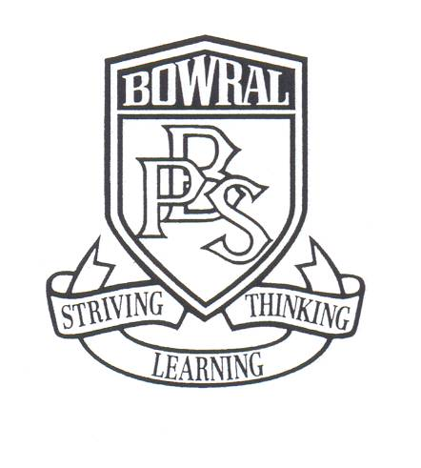
Bowral Public School
PO Box 865
Bendooley Street
BOWRAL NSW 2576

Telephone: (02) 4861 1086 Facsimile: (02) 4862 1004
Email: bowral-p.school@det.nsw.edu.au

BALLROOM DANCING LESSONS

Dear Parents, 6 September, 2017

6 Cobalt, 6 Indigo and 6 Turquoise will be participating in ballroom dancing lessons in Term 4.

These lessons are run by professional dance instructor, Keith Nicholson and provide students with the opportunity to learn skills which form an important part of the PDHPE syllabus and aim to develop fitness, coordination, physical control and social skills. These lessons, which will be held in class groups, culminate in the end of year dinner dance.

The cost of this program is $36.00.

We encourage all students to participate in these enjoyable and enriching lessons.

Please complete the slip below and return to your child’s class teacher by Thursday 21 September, 2017.
Unfortunately, if payment is not received, students will not be able to participate in this program.

If you have any questions about this event, please do not hesitate to contact your child’s teacher.

Kind regards,

_____________________________ ____________________________
Eva Canute Wendy Buckley, Principal

Unfortunately no late payments can be accepted. Payment may be made by our parent online payment option which is accessed on the ribbon of our web page by selecting $ - make a payment. Payment can also be made by cash or cheque to your child’s class teacher. If you are having difficulty making this payment, please do not hesitate to make an appointment to speak to Mrs Buckley or Ms Christie regarding financial assistance. Any arrangements made will remain confidential.
------------------------------------------------------------------------------------------------
BOWRAL PUBLIC SCHOOL Y6 BALLROOM DANCING

Payment Note: To the Teacher: __________________________________ Class: ___________

I/We enclose $36.00 payment for my/our child ________________________ to attend the ballroom dancing lessons in Term 4.

Payment by: POP  POP receipt number ———–————
CASH     CHEQUE 

